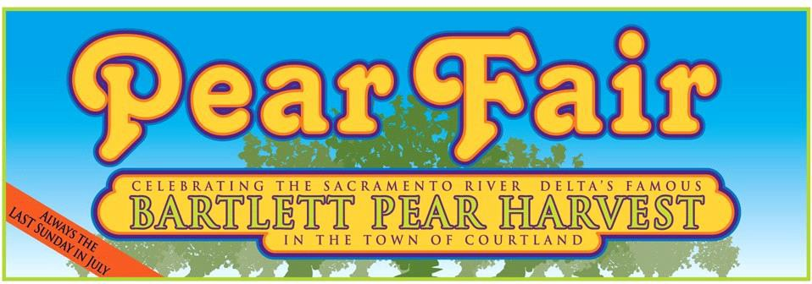

Dear Friends and Neighbors,
Due to the COVID-19 Pandemic, we were forced to cancel the Pear Fair in 2020 & 2021. We returned in 2022 with a very successful fair and we owe a huge part of that to you, our amazing sponsors!!
On Sunday, July 3oth, 2023, the Sacramento River Delta town of Courtland will host the 49th Pear Fair, the oldest agricultural fair in California and the largest event in the Sacramento Delta.
The Pear Fair is a non-profit family event that draws over 5,000 people from the community and throughout the area. We offer a variety of pear themed displays, historical area displays, arts & crafts, live music, children’s events, and an array of foods & beverages that feature our local pears and produce. We also are home to one of the last MILE runs in the region – a ½ mile run through town for the kids and 5 & 10 Mile Country Runs.
We are very fortunate to have the support of local businesses and community members who donate to the Pear Fair each year. By doing so, you are supporting the community in more ways than you know. Our local non-profits sell food or craft items that generate over $50,000 to benefit our local athletic programs, scholarships, fire association, library, schools, and the list goes on…
The fair is such an integral part of our community and your donation is very important to continue this tradition. As we have in the past, we will display your personal or company name, in our printed and electronic advertisements. Additionally, we will prepare a dinner for you and your family on Saturday, July 29th under the “big” tent. Here, we will introduce you to the Royal Court Applicants, the Milo Wetzel Scholarship Recipient, Event Volunteers, and you will also get a sneak peek at the Pear Fair schedule of events and activities.
Again, we cannot thank you enough for your generous donation and we promise to do our part to
make the return of Pear Fair more special than ever before!

Sincerely,
The Pear Fair “Core” Volunteers
CourtlandPearFair@gmail.com

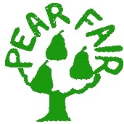
Please Support one of the Delta's Longest Summer Traditions
YES, I will support the 2023 Pear Fair by contributing:

⃝ $1000 - Incom-Pear-Able Sponsor ⃝ $300 - Pear-Digious Sponsor Highly visible site designated for your booth Advertisement in event program Recognition on Pear Fair website Recognition on Pear Fair website
Advertisement in event program 3 complimentary parking passes Listing on main event banner
10 parking passes ⃝ $200 - Su-Pear Sponsor
2 drink passes Recognition on Pear Fair website 2 complimentary parking passes
⃝ $500 - Pear-fect Sponsor
Site designated for your company booth ⃝ Under $200/Other - Pear-Tastic Sponsor Advertisement in event program (We are always grateful for event prizes) Recognition on Pear Fair website Recognition on Pear Fair website
5 parking passes Complimentary parking pass

Will we see you Saturday, July 29th at the Pear Fair Sponsor Dinner?

⃝ Yes! _ # of Guests ⃝ Maybe? ⃝ Not this Year

Name as I would like it to appear:
Contact Person: Phone Number: Address:
Company Website address (if applicable):
Email Address:
Amount of space needed for company booth (booth not provided):

Dinner starts at 6pm, located under the "big" tent on the Courtland Fairgrounds.

